Indonesia Underscores ASEAN Outlook on Indo-Pacific (AOIP) Importance
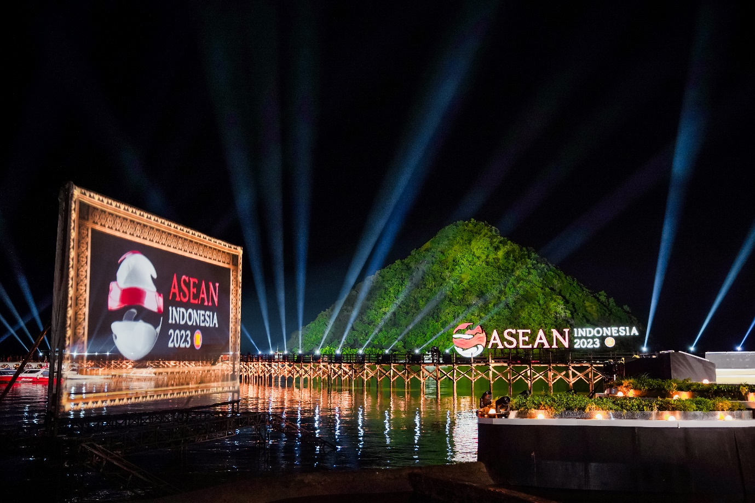
Ayana Komodo Waecicu Beach becomes the ASEAN leaders' welcoming dinner venue at the 42nd ASEAN Summit in Labuan Bajo, East Nusa Tenggara. (Photo: ASEAN2023 Host Photographer)

The ASEAN Outlook on Indo-Pacific (AOIP) is an affirmation of the Association of Southeast Asian Nations (ASEAN) role to maintain peace, security, stability, and prosperity in the Indo-Pacific (Indian Ocean and Asia Pacific) region. This Outlook puts forward an open and inclusive dialogue and cooperation in the ASEAN's priority areas: maritime, economy, connectivity, and the Sustainable Development Goals (SDGs).
The AOIP responds to the Quadrilateral Security Dialogue (QSD) presence in the Indo-Pacific region. The formation and transformation of QSD cooperation in the dynamic Indo-Pacific have caused reactions and assumptions from countries in the region, especially in Southeast Asia. At the 2019 ASEAN Summit in Bangkok, Indonesia introduced the AOIP as a shared vision and guideline for countries in the Indo-Pacific region to respond to the situation.
The AOIP is a regional architecture initiative with the ASEAN concept at its foundation. The AOIP adopted at the 34th ASEAN Summit in Thailand in 2019 was intended as an engagement guide for ASEAN in the Asia-Pacific and Indian Ocean regions. At that time, the AOIP mentioned ”security” in a limited way and focused only on maritime. Meanwhile, the "defense" was only mentioned once and referred to the ADMM role strengthening.
On 15 June 2021, the ASEAN Defense Ministers' Meeting issued a discussion script on AOIP from a defense perspective. One of the six principles stated that any form of ASEAN defense cooperation with other countries must achieve 10 ASEAN member states' consensus to maintain the security and stability of the region.
The AOIP became one of the main discussion agendas at the 42nd ASEAN Summit in Labuan Bajo, West Manggarai, East Nusa Tenggara, on 9—11 May 2023. President Joko Widodo underscored that Indonesia, the chair of ASEAN 2023, will strengthen the Association's role in facing challenges, responding to dynamics, and playing a central role in the region. With the growing rivalry in the Indo-Pacific, ASEAN leaders agreed that the AOIP is more vital than ever. The initiative adopts the cooperation, inclusiveness, and concreteness paradigm in its implementation.
The AOIP is a way to maintain the stability of the Indo-Pacific region and ASEAN member countries. In its implementation, AOIP still has many challenges that must be addressed, particularly in the accommodation of the interests of each country in the Indo-Pacific region.
Indonesia continues to voice three main principles of the ASEAN Outlook on Indo-Pacific, namely ASEAN centrality, inclusivity, and complementarity. ASEAN centrality is urgently needed amid geopolitical and geostrategic dynamics in the Indo-Pacific region. AOIP opens dialogue and cooperation with all countries without exception. The Outlook also emphasizes synergies amid differences in the Indo-Pacific concept and aims to strengthen existing mechanisms in facing regional and global challenges.
So far, several ASEAN members have defense and security cooperation with various countries outside the region. Indonesia, Thailand, Singapore, and the Philippines have a regular military exercises with the United States. On the other hand, China cooperates with Cambodia and Vietnam in military matters.
Regarding the AOIP implementation, President Joko Widodo sees the need for concrete and inclusive cooperation to reduce tensions in the Indo-Pacific, for instance, the ASEAN Indo-Pacific Infrastructure Forum.

Sources:
- kemlu.go.id
- www.kompasiana.com
- www.kemhan.go.id
- www.kompas.id

